FINAL PROJECT REPORT
Employee Raise Issue – Record Producer & Service Portal Integration Guide
Employees Raise Workplace / IT Issues Through a ServiceNow Employee Center Portal
Name | Namburi Sriya Ram
Team ID | Individual
Platform | ServiceNow (Employee Center / Service Portal)
Portal | https://dev402706.service-now.com/employee_request
GitHub | SriyaRam12/employee-issue-management-servicenow
Date | 20 September 2026

TABLE OF CONTENTS
1. INTRODUCTION
1.1 Project Overview
1.2 Purpose
2. IDEATION PHASE
2.1 Problem Statement
2.2 Empathy Map Canvas
2.3 Brainstorming
3. REQUIREMENT ANALYSIS
3.1 Customer Journey Map
3.2 Solution Requirement
3.3 Data Flow Diagram
3.4 Technology Stack
4. PROJECT DESIGN
4.1 Problem Solution Fit
4.2 Proposed Solution
4.3 Solution Architecture
4.4 Implementation Details
5. PROJECT PLANNING & SCHEDULING
5.1 Project Planning
6. FUNCTIONAL AND PERFORMANCE TESTING
6.1 Functional Testing
6.2 Performance Testing
7. RESULTS
7.1 Output Screenshots
7.2 Summary of Results
8. ADVANTAGES & DISADVANTAGES
9. CONCLUSION
10. FUTURE SCOPE
11. APPENDIX
A. Record Producer Configuration
B. Widget Source
C. GitHub & Project Demo Link
D. Core ServiceNow Records Used
E. Acceptance Criteria

1. INTRODUCTION

1.1 Project Overview
The project, “Employee Raise Issue Management System using ServiceNow”, is a ServiceNow Employee Center / Service Portal based application that gives employees a centralised place to raise workplace and IT-related issues. The employee opens the portal, goes to Raise an Issue, and submits a structured form provided by the Record Producer “Raise Employee Issue”. On submission, ServiceNow creates an Employee Issue record (ticket) in a custom Employee Raise Issue table. During testing, a submission created the ticket EMP0001004.
The solution is built as a custom ServiceNow application containing a custom table, a Record Producer with catalog variables mapped to the table fields, and UI policies / dependencies for the Employee Issue form. The portal experience is customised with Service Portal Designer and a custom Commercial Services widget written in HTML and CSS/SCSS. The application is connected to GitHub for source control.
Scope of the implemented version: issue creation and record management. The project is not AI-based and does not include automated issue resolution, automatic assignment, SLA automation, notifications, Flow Designer workflows or REST integrations. Such capabilities are listed only as Future Enhancements in Section 10.

1.2 Purpose
The purpose of the project is to make it simpler for employees to raise workplace / IT issues and to ensure each issue is captured as a structured, trackable record in ServiceNow.
- Provide a centralised Employee Center / Service Portal from which employees can raise issues.
- Provide a structured issue form through the Record Producer “Raise Employee Issue”.
- Capture Requester, Category, Subcategory, State and Short Description for every issue.
- Create an Employee Issue record in a custom Employee Raise Issue table on submission.
- Support tracking and management of the issue records in ServiceNow.
- Provide a customised portal experience with a custom Commercial Services widget.
- Manage the application through GitHub source control.

2. IDEATION PHASE

2.1 Problem Statement
Employees regularly face workplace and IT issues such as network (for example VPN), hardware (laptop, server), software and access (forgotten password) problems. When there is no single, structured way to report these issues, reports are made through scattered informal channels, often lack details such as category or requester, and are not captured as dedicated records. This makes issues harder to track and manage, and leaves employees uncertain about whether their issue has been recorded.
Final Customer Problem Statement: I am an employee who faces a workplace or IT issue. I am trying to report it clearly to the right place, but there is no single structured way to raise it, so reports can be scattered and incomplete, which makes me feel uncertain about whether my issue has been recorded.

2.2 Empathy Map Canvas
The empathy map focuses on the employee as the primary user who raises issues through the Employee Center portal. It was prepared from an analysis of the problem context.
Think & Feel  What does the user think and feel?  - I need this problem fixed so I can continue my work.  - Where do I report this?  - Has my issue been recorded?  - I hope the process is simple and clear. | Hear  What does the user hear?  - Colleagues suggest different ways of contacting IT.  - Instructions from a manager or IT about reporting problems.  - IT policies about equipment and access.
See  What does the user see?  - The Employee Center portal with Search, Quick Links, My Active Items and Recommended for You.  - A Raise an Issue section.  - The Raise Employee Issue form.  - The Commercial Services widget. | Say & Do  What does the user say and do?  - Opens Employee Center.  - Goes to Raise an Issue and opens Raise Employee Issue.  - Selects requester, category, subcategory and state; enters a short description; adds an attachment if required.  - Submits the issue.
Pain  What are the user’s pains or frustrations?  - No single place to report issues.  - Free-form reports miss details.  - Unsure whether the issue was recorded.  - Not sure how to categorise the issue. | Gain  What does the user hope to achieve?  - One clear entry point.  - A structured form with predefined choices.  - A ticket record created on submission.  - Record tracked / managed in ServiceNow.
Figure 1. Empathy Map – Employee raising a workplace / IT issue
- Needs: one clear place to raise an issue, a simple structured form, and a record of the submitted issue.
- Pain points: scattered reporting channels, incomplete reports and uncertainty about whether the issue was logged.
- Expected gain: a consistent submission experience and a ticket record that can be tracked and managed in ServiceNow.

2.3 Brainstorming
Brainstorming was used to identify practical ideas that could improve how employees raise issues. Ideas were grouped into issue submission, data capture, portal experience and future automation. The table separates ideas that were implemented from those planned as Future Enhancements.
Idea | Importance | Feasibility | Status
Employee Center portal as a single entry point | High | High | Implemented
Record Producer issue form | High | High | Implemented
Custom Employee Raise Issue table | High | High | Implemented
Category / Subcategory / State choice fields | High | High | Implemented
UI policies for field dependencies | Medium | High | Implemented
Custom Commercial Services widget | Medium | High | Implemented
GitHub source control | Medium | High | Implemented
Automatic assignment to support groups | High | Medium | Future Enhancement
Automated notifications | Medium | High | Future Enhancement
SLA management and escalation | Medium | Medium | Future Enhancement
Flow Designer workflow and automated state transitions | High | Medium | Future Enhancement
Knowledge article recommendations | Medium | Medium | Future Enhancement
Dashboards and analytics | Medium | High | Future Enhancement

Selected idea: provide a ServiceNow Employee Center portal with a Record Producer that creates issue records in a custom table. This idea was selected because it directly addresses the identified problem and can be implemented with standard ServiceNow capabilities.

3. REQUIREMENT ANALYSIS

3.1 Customer Journey Map
The journey describes the employee experience from facing an issue to having a record in ServiceNow. The stages are Awareness, Access, Raise Issue, Submit and Follow-up. The emotional row shows the intended experience; the Opportunities row lists Future Enhancements only.
Stage | 1. Awareness | 2. Access | 3. Raise Issue | 4. Submit | 5. Follow-up
Steps | Employee faces a network, software, hardware or access problem. | Opens the Employee Center portal. | Goes to Raise an Issue, opens Raise Employee Issue and fills in the form. | Submits the issue. | An issue record exists in ServiceNow.
Interactions | Colleagues, manager or IT staff (informal). | Employee Center homepage, Search, Quick Links. | Record Producer form; attachment if required. | Submit action on the form. | Employee Raise Issue record (e.g. EMP0001004).
Goals | Find where to report the issue. | Reach the right place quickly. | Describe the issue clearly. | Get the issue recorded. | Have the issue tracked and managed.
Positive moments | A clear entry point exists. | One portal with a visible Raise an Issue section. | Predefined choices simplify categorising. | A ticket record is created. | Record can be tracked / managed in ServiceNow.
Negative moments (without a structured process) | Unsure whom to contact. | Several channels to choose from. | Free-form reports miss details. | Unsure if the report was logged. | No dedicated record to follow up.
Opportunities (Future) | Knowledge article recommendations. | Dashboards and analytics. | Approval workflow where required. | Automated notifications. | Automatic assignment, SLA, escalation, resolution notes.
Intended emotion | Concerned | Hopeful | Focused | Reassured | Informed
Figure 2. Customer Journey Map – Raising an Employee Issue
The main opportunity areas are a single clear entry point, complete information capture through a structured form, and a dedicated record for every submitted issue.

3.2 Solution Requirement
The following functional and non-functional requirements describe the behaviour and quality characteristics of the solution. The Status column shows what is implemented in the current version.

Functional Requirements
FR No. | Functional Requirement | Sub Requirement / Expected Behavior | Status
FR-1 | Portal Access | Employees can open the Employee Center-based Service Portal (https://dev402706.service-now.com/employee_request), which provides Search, Raise an Issue, Raise Ticket, Quick Links, My Active Items and Recommended for You. | Implemented
FR-2 | Issue Submission Form | The Record Producer “Raise Employee Issue” lets the employee enter issue information in a structured form. | Implemented
FR-3 | Requester Capture | The Requester variable is a reference to the sys_user table. | Implemented
FR-4 | Categorisation | Category (Network, Software, Hardware, Access) and Subcategory (VPN, Laptop, Server, Forgot Password) are multiple-choice variables. | Implemented
FR-5 | State Capture | State (New, In Progress, Resolved, Closed) is a multiple-choice variable mapped to the State field. | Implemented
FR-6 | Short Description | A single-line text variable captures the short description of the issue. | Implemented
FR-7 | Attachment | The employee can add an attachment if required. | Implemented
FR-8 | Record Creation | Submitting the form creates an Employee Issue record in the custom Employee Raise Issue table, with variables mapped to the table fields. | Implemented
FR-9 | Record Tracking / Management | Employee Issue records can be tracked and managed in ServiceNow. | Implemented
FR-10 | Form Behaviour | UI policies / dependencies configured for category / subcategory and field behaviour on the Employee Issue form. | Implemented
FR-11 | Portal Customisation | A custom Commercial Services widget (HTML, CSS/SCSS) is displayed on the Employee Center homepage. | Implemented
FR-12 | Source Control | The ServiceNow application is connected to and committed to the GitHub repository SriyaRam12/employee-issue-management-servicenow. | Implemented

Non-functional Requirements
NFR No. | Requirement | Description | Status in this project
NFR-1 | Usability | The issue form should be simple and easy for employees to use. | Addressed through a short form with predefined choices.
NFR-2 | Security | Only authorised users should access the portal and records. | Relies on ServiceNow platform features; no custom security controls or security testing are documented.
NFR-3 | Reliability | Submissions should create records without losing information. | Verified for the test submissions performed (e.g. EMP0001004).
NFR-4 | Performance | Submission should complete in acceptable time. | Not formally measured.
NFR-5 | Availability | The portal should be available when employees need it. | Depends on the ServiceNow instance; not separately tested.
NFR-6 | Scalability | The solution should be extendable to more users, issues and fields. | Design supports extension; no load testing performed.
NFR-7 | Maintainability | Changes should be traceable and manageable. | Application connected to GitHub source control.

3.3 Data Flow Diagram
The data flow shows how an issue moves through the platform. The employee submits issue details through the Employee Center portal and the Raise Employee Issue Record Producer. The Requester is looked up in the sys_user table, and a new record is stored in the Employee Raise Issue table. Authorised ServiceNow users can then track and manage the stored records.
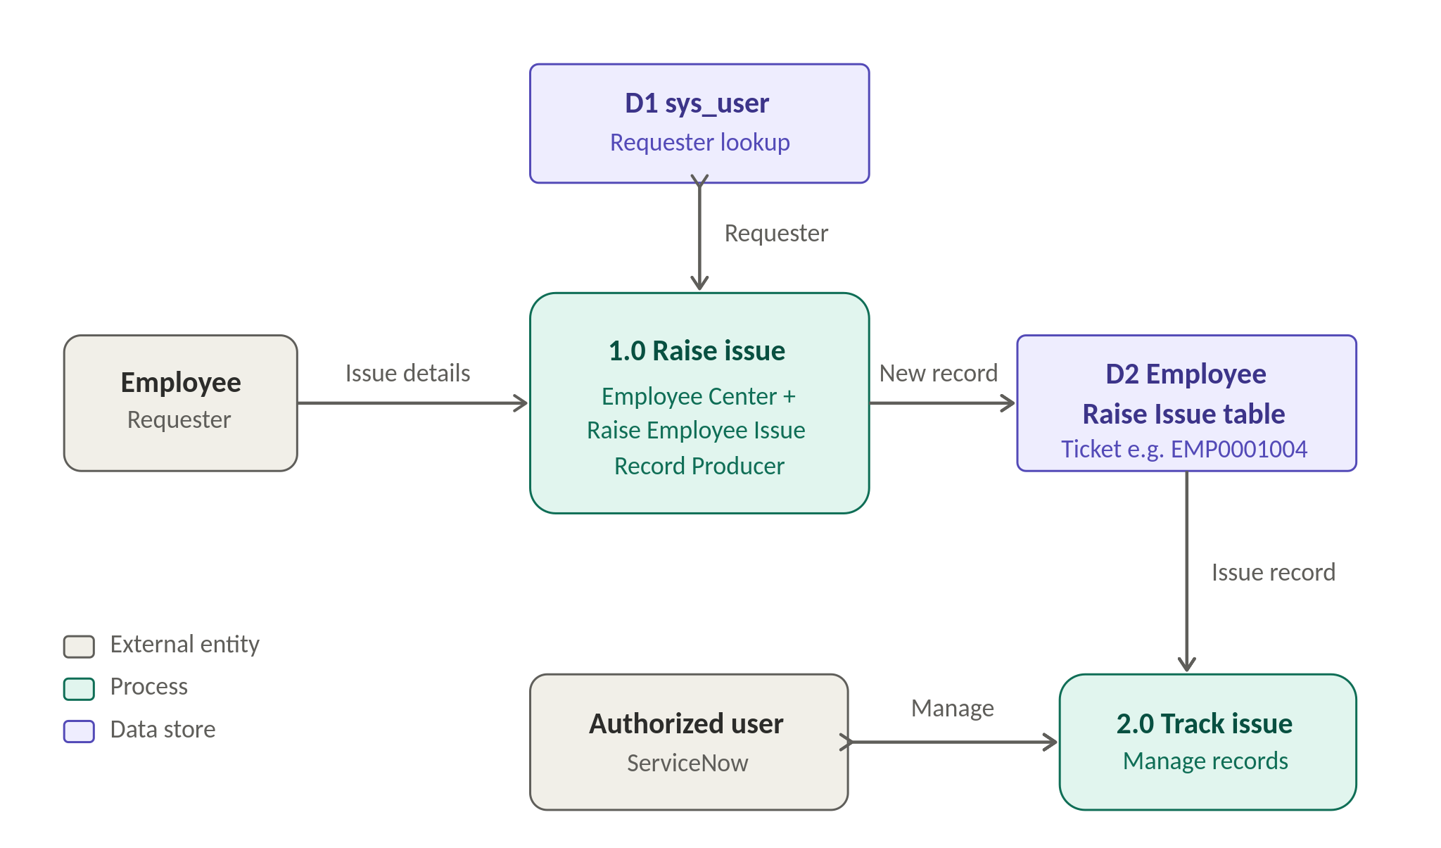
Figure 3. Data Flow Diagram (Level 0) – Employee Raise Issue Management System
Stage | ServiceNow Record / Table | Purpose
Portal entry | Employee Center / Service Portal | Employee opens the portal and goes to Raise an Issue.
Issue form | Record Producer “Raise Employee Issue” | Captures the issue information through variables.
Requester lookup | sys_user | Provides the Requester reference.
Issue record | Employee Raise Issue (custom table) | Stores each submission as a record with a ticket number.
Tracking / management | Employee Raise Issue records in ServiceNow | Records are tracked and managed in ServiceNow.

3.4 Technology Stack
Component | Technology | Purpose
Platform | ServiceNow | Hosts the application, portal, tables and records.
User Interface | Employee Center / Service Portal; Service Portal Designer | Employee accesses the portal and raises the issue.
Custom Widget | Service Portal widget with HTML and CSS/SCSS | Displays the Commercial Services section.
Application | Custom ServiceNow application | Contains the table, Record Producer and UI policies.
Data | Custom Employee Raise Issue table; sys_user | Stores issue records; provides requester reference.
Issue Form | Record Producer with catalog / record-producer variables | Captures issue information and maps it to table fields.
Form Behaviour | UI policies / field dependencies | Category / subcategory and field behaviour.
Configuration | ServiceNow configuration and scripting | Application configuration.
Source Control | GitHub | Version control and project documentation.
Infrastructure | ServiceNow instance dev402706 | Hosts and runs the application and portal.

4. PROJECT DESIGN

4.1 Problem Solution Fit
The problem-solution fit is achieved by replacing scattered, unstructured issue reporting with a single Employee Center portal and a structured Record Producer that stores every issue as a record in a custom table.
Canvas Area | Project-Specific Definition
Customer Segments | Employees who face workplace / IT issues (network, software, hardware, access) and need to report them; secondary users are authorised ServiceNow users who track and manage the records.
Jobs-to-be-Done / Problems | Report an issue quickly from one place, describe it in a consistent format, and have it recorded. Problems: scattered reports, missing details and no central record.
Problem Root Cause | No single centralised entry point; free-form reports omit details; no dedicated record for each issue.
Triggers | A sudden problem such as VPN not connecting, a laptop or server issue, software not working or a forgotten password; being unable to continue work.
Available Solutions | Email, phone or verbal reports, informal chat and general ticketing forms: quick or structured, but not tailored to the Category / Subcategory / State fields of this project.
Customer Constraints | Employees are not always technical, have limited time and need a browser and network access to reach the portal.
Behaviour | Employees currently report through informal channels and follow up repeatedly. With the solution they open Employee Center, go to Raise an Issue, fill in the form and submit.
Channels of Behaviour | Online: Employee Center portal (https://dev402706.service-now.com/employee_request). Offline: phone calls and in-person reports, which the portal aims to reduce reliance on; it does not integrate with them.
Emotions | Before: frustrated and unsure whom to contact. After (intended): reassured because a ticket record is created.
Your Solution | Employee Center portal + Record Producer “Raise Employee Issue” + custom Employee Raise Issue table + UI policies + Commercial Services widget.

4.2 Proposed Solution
The proposed solution is a custom ServiceNow application delivered through an Employee Center-based Service Portal. The employee flow is:
- The employee opens the Employee Center portal.
- The employee goes to Raise an Issue and opens Raise Employee Issue.
- The employee enters the Requester, selects Category, Subcategory and State, and enters a Short Description.
- The employee adds an attachment if required and submits the issue.
- ServiceNow creates an Employee Issue record in the Employee Raise Issue table (tested: EMP0001004).
- The record can be tracked and managed in ServiceNow.

Parameter | Proposed Solution
Problem to be solved | Lack of a centralised, structured way for employees to report workplace / IT issues, leading to scattered, incomplete reports without dedicated records.
Idea / Solution | Employee Center portal with a Record Producer that captures structured issue information and creates records in a custom Employee Raise Issue table.
Novelty / Uniqueness | A tailored combination of a purpose-built custom application and table, one-to-one variable mapping with predefined choices, and a portal customised with a custom widget. It is not AI-based and does not rely on automation.
Customer Satisfaction | A clear entry point and a ticket record on submission (test record EMP0001004). Benefits are design-level expectations; no satisfaction measurement was performed.
Business Value | Academic / internal-use project; no revenue model is implemented. The value is better structure and visibility of employee issues.
Scalability | Built on a cloud platform; categories, fields and portal content can be extended. Functionally tested only, without load testing.

4.3 Solution Architecture
The architecture connects the employee, the Employee Center portal, the Raise Employee Issue Record Producer and the custom Employee Raise Issue table inside a custom ServiceNow application. sys_user provides the requester reference, UI policies apply to the Employee Issue form, and the application is committed to GitHub. Planned enhancements are shown separately and are not implemented.
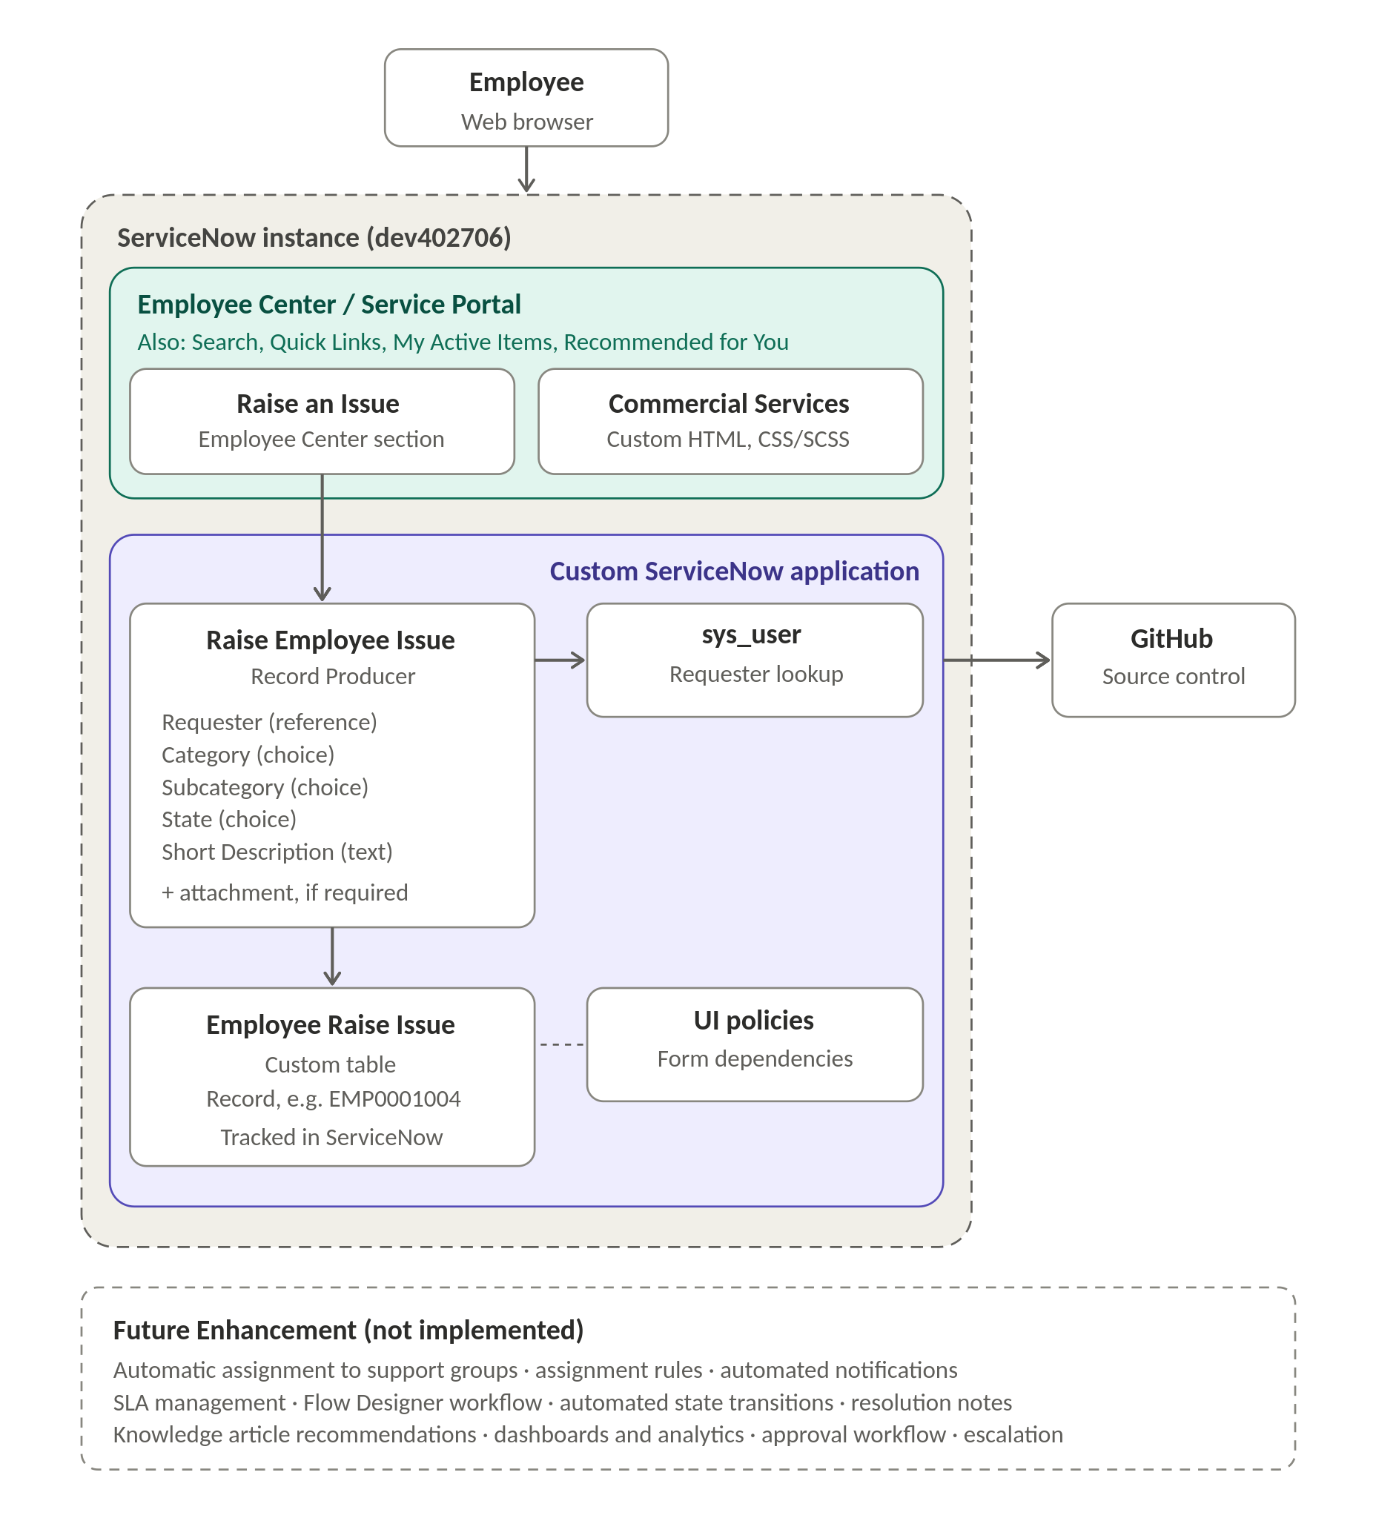
Figure 4. Solution Architecture – Employee Raise Issue Management System using ServiceNow
Component | Purpose
Employee | Raises the issue through a web browser.
Employee Center / Service Portal | Entry point with Search, Raise an Issue, Raise Ticket, Quick Links, My Active Items and Recommended for You.
Commercial Services widget | Custom widget (HTML, CSS/SCSS) displayed on the homepage; informational content only.
Custom ServiceNow application | Contains the Record Producer, custom table and UI policies.
Record Producer “Raise Employee Issue” | Captures Requester, Category, Subcategory, State and Short Description (attachment if required).
sys_user | Reference table for the Requester variable.
Employee Raise Issue table | Custom table that stores each submitted issue as a record.
UI policies | Category / subcategory and field behaviour on the Employee Issue form.
GitHub | Repository SriyaRam12/employee-issue-management-servicenow; the application was committed through ServiceNow’s source-control integration.

4.4 Implementation Details

4.4.1 Custom Application and Employee Raise Issue Table
A custom ServiceNow application was created for the project, and a custom Employee Raise Issue table was created inside it. The system generates a ticket record for every submission.
Field | Purpose | Values / Notes
Requester | User who raised the issue | Reference to a user (sys_user)
Category | Type of issue | Network, Software, Hardware, Access
Subcategory | More specific issue type | VPN, Laptop, Server, Forgot Password
State | Issue state | New, In Progress, Resolved, Closed
Short Description | Brief description of the issue | Single-line text
Ticket number | Identifies the record | Generated by the system, e.g. EMP0001004
Other fields | As required by the project | Not itemised in this report
Although the State choices exist, the current version does not implement an automated issue-resolution workflow or automated state transitions.

4.4.2 Record Producer and Variable Mapping
The Record Producer “Raise Employee Issue” creates records in the Employee Raise Issue table. Its variables are mapped to the corresponding table fields (full configuration in Appendix A).
Variable | Type | Question | Mapped field | Order
Requester | Reference (sys_user) | What is the Requester name | Requester | 100
Category | Multiple Choice | Which Category | Category | 200
Subcategory | Multiple Choice | What is Subcategory | Subcategory | 300
State | Multiple Choice | Which State is this issue | State | 400
Short Description | Single Line Text | Short description | Short Description | 500

4.4.3 UI Policies / Dependencies
UI policies / dependencies were configured for the Employee Issue form, covering category / subcategory behaviour and field behaviour as required by the project. No additional UI policies beyond these were implemented.

4.4.4 Service Portal Design
An Employee Center-based Service Portal was created and configured using Service Portal Designer. The demo portal is https://dev402706.service-now.com/employee_request.
Portal Area | Description
Employee Center homepage | Landing page of the portal, customised for the project.
Search | Search area on the homepage.
Raise an Issue / Raise Ticket | Entry point to the issue-raising workflow and the Raise Employee Issue Record Producer.
Quick Links | Shortcut links on the homepage.
My Active Items | Section listing the employee’s active items.
Recommended for You | Recommendation section on the homepage.
Commercial Services | Custom widget added to the homepage.

4.4.5 Custom Commercial Services Widget
A custom Service Portal widget, used as the Commercial Services widget, was created with custom HTML and CSS/SCSS and added to the Employee Center homepage.
Property | Specification
Heading | “Our Commercial Services” (blue heading)
Content items | 24/7 Customer Support; Faster Issue Resolution; Transparent Tracking; Secure & Reliable. These are informational statements displayed on the widget, not automated features.
Background | Green / white / blue gradient
Card design | Rounded card with box shadow and padding; responsive card layout
List styling | Check-mark list with custom typography
Technologies | HTML and CSS/SCSS

4.4.6 Source Control
The ServiceNow application was connected to the GitHub repository SriyaRam12/employee-issue-management-servicenow and successfully committed. The repository is intended to hold project documentation, widget HTML/CSS, screenshots, architecture and design documentation, requirements, testing documentation and implementation evidence. The whole ServiceNow instance is not represented as ordinary source-code files; application metadata is stored through ServiceNow’s source-control integration.

5. PROJECT PLANNING & SCHEDULING

5.1 Project Planning
The project work was organised into the phases and user stories below, derived from the implemented features. Sprint durations and story-point estimates are not included in this report.
ID | Phase / Epic | User Story / Work Item | Status
US-01 | Application setup | Create the custom ServiceNow application and the custom Employee Raise Issue table. | Completed
US-02 | Issue form | As an employee, I want a structured form to describe my issue consistently (Record Producer with five mapped variables). | Completed
US-03 | Form behaviour | As an employee, I want the form fields to behave consistently (UI policies / dependencies). | Completed
US-04 | Portal | As an employee, I want one portal where I can find Raise an Issue (Employee Center / Service Portal). | Completed
US-05 | Submission | As an employee, I want my submission to create a ticket record (verified with EMP0001004). | Completed
US-06 | Portal customisation | As an employee, I want to see the Commercial Services section on the homepage (custom widget). | Completed
US-07 | Source control | As a developer, I want the application under version control (GitHub commit). | Completed
US-08 | Testing | Test the portal, form, choices, submission, record creation and widget display. | Completed
FE-01 | Automation | Assignment rules, notifications, SLA management, Flow Designer workflow and escalation. | Future Enhancement

6. FUNCTIONAL AND PERFORMANCE TESTING

6.1 Functional Testing
Functional testing verified the end-to-end path from the Employee Center portal to the creation of an Employee Issue record, together with the choice fields and the custom widget.
TC ID | Test Area | Expected Outcome | Result
TC-01 | Employee Center accessibility | The Employee Center portal opens at the project URL. | Pass
TC-02 | Raise Employee Issue availability | Raise Employee Issue is available under Raise an Issue. | Pass
TC-03 | Record Producer form | The form loads with the variables for Requester, Category, Subcategory, State and Short Description. | Pass
TC-04 | Category choices | Network, Software, Hardware and Access are available. | Pass
TC-05 | Subcategory choices | VPN, Laptop, Server and Forgot Password are available. | Pass
TC-06 | State choices | New, In Progress, Resolved and Closed are available. | Pass
TC-07 | Short description | A short description can be entered. | Pass
TC-08 | Submission | The issue can be submitted from the form. | Pass
TC-09 | Record creation | An Employee Issue record / ticket is created (e.g. EMP0001004). | Pass
TC-10 | Commercial Services widget | The custom widget displays “Our Commercial Services” on the portal. | Pass
Summary: 10 of 10 test cases passed, as reported from the testing performed. The following were not separately tested and are therefore not claimed: attachment upload, detailed UI policy behaviour, security controls and load or stress conditions.

6.2 Performance Testing
No load, stress or response-time testing was performed. The tests above are functional, based on individual test submissions on the ServiceNow instance dev402706. Performance and scalability characteristics are therefore not measured and are not claimed.

7. RESULTS

7.1 Output Screenshots
The following evidence points are to be inserted from the ServiceNow instance. Each placeholder is placed below its corresponding result.
Output 1 – Employee Center Homepage
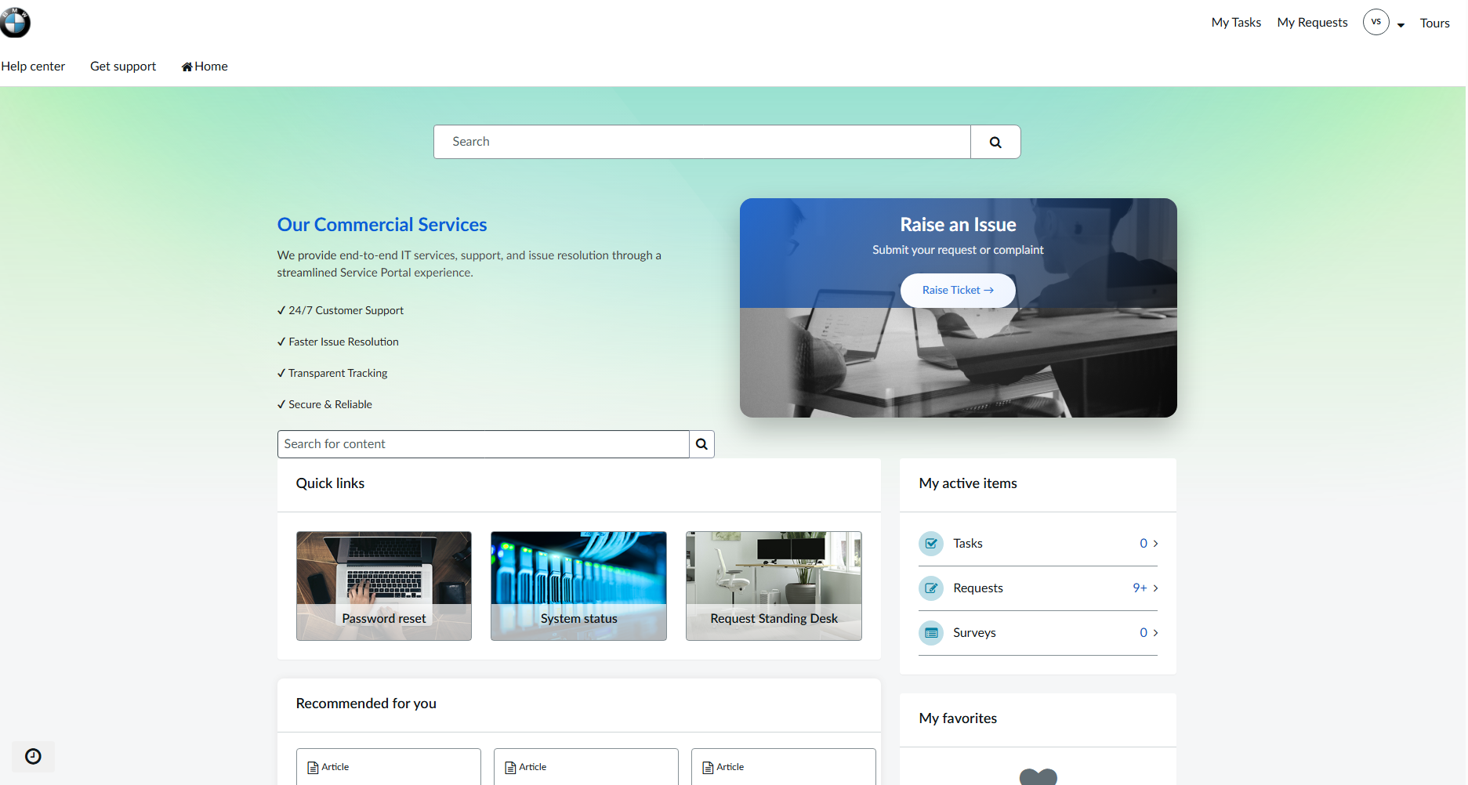Output 2 – Custom Commercial Services Widget
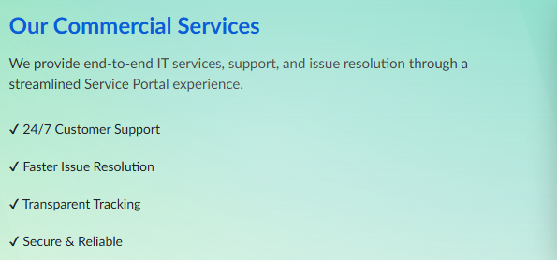
Output 3 – Raise Employee Issue Form
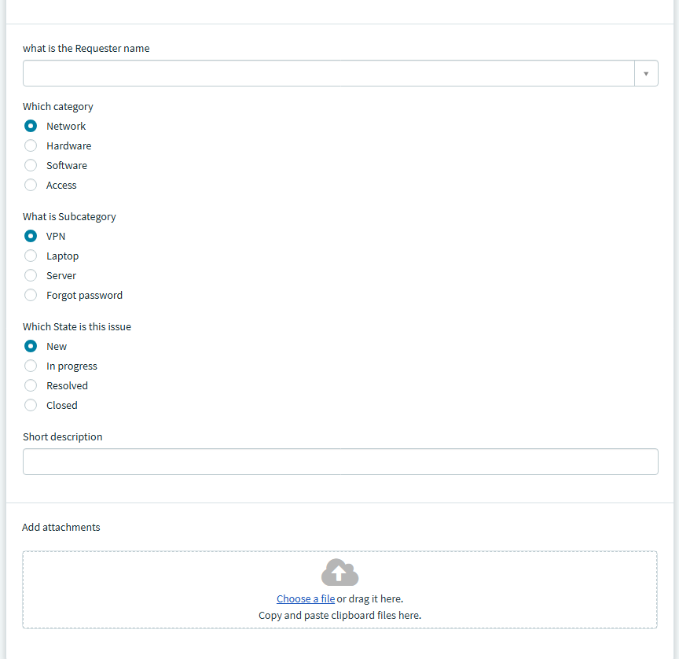 Output 4– Successful Submission and Ticket Record
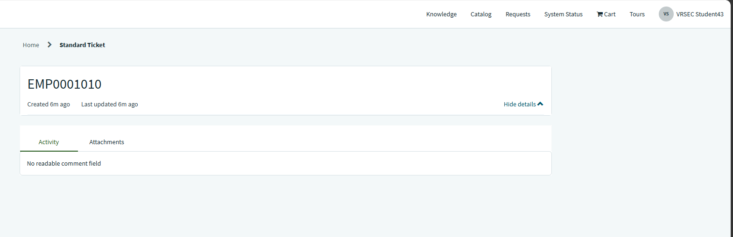Output 6 – Employee Raise Issue Table
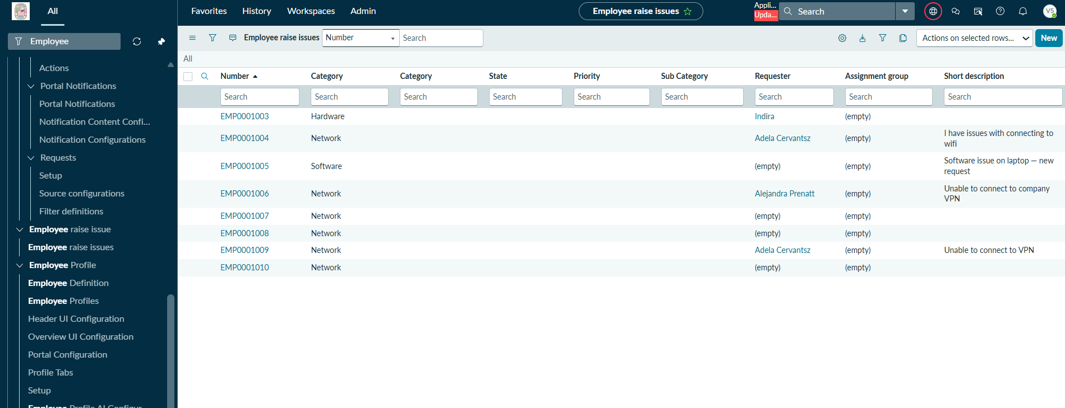

Output 7
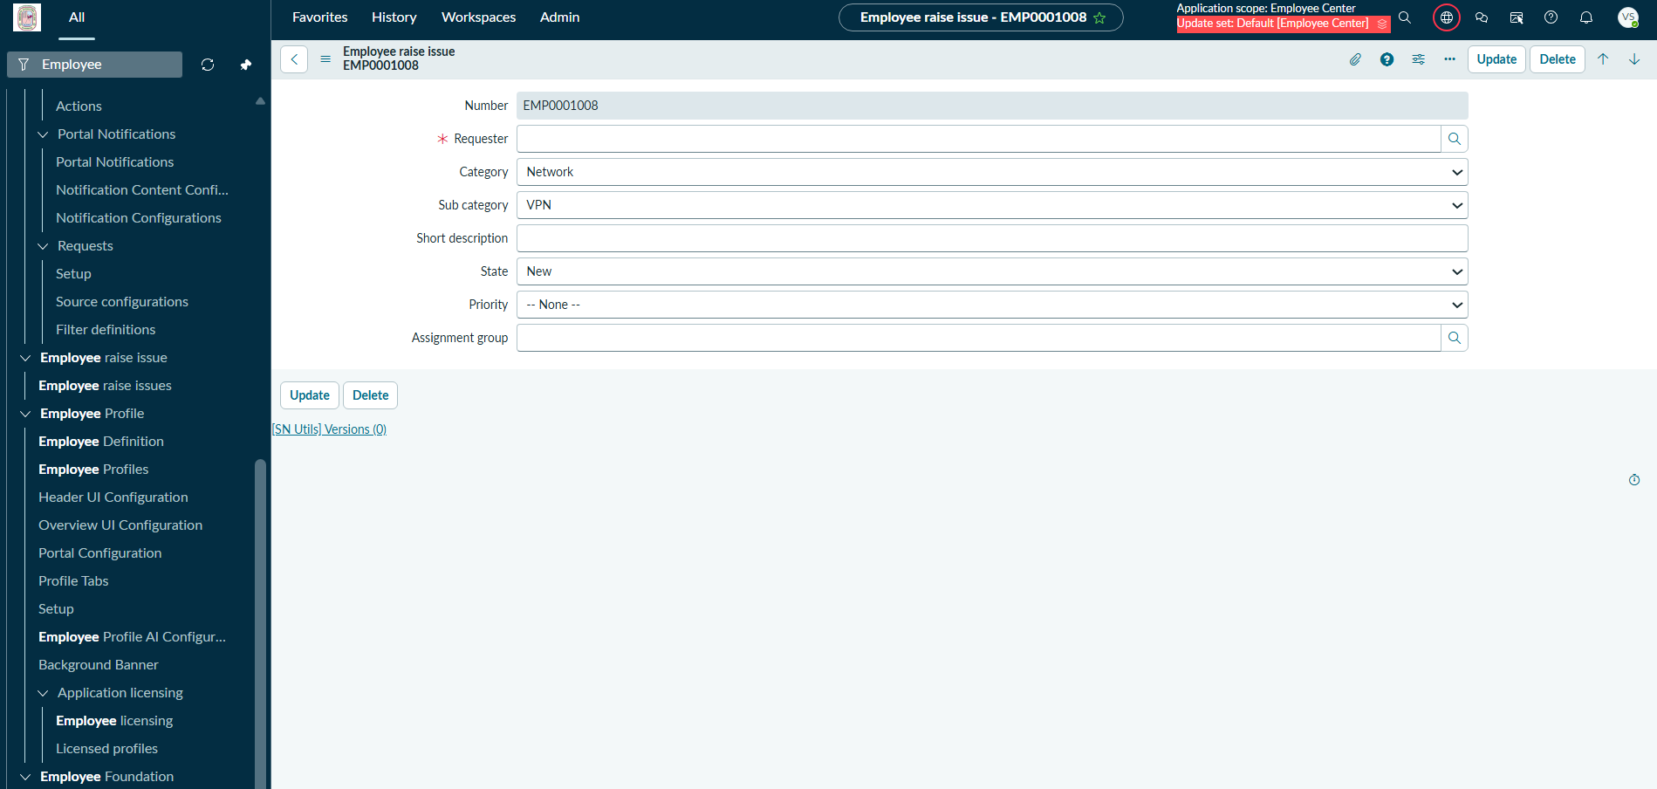
Output 8 – GitHub Repository
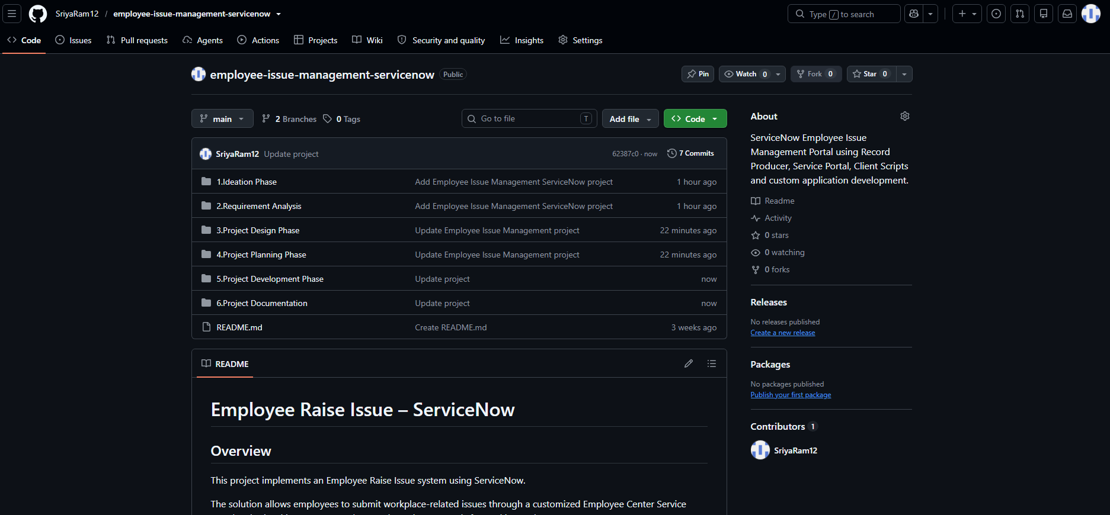

7.2 Summary of Results
Objective | Result | Status
Centralised portal for raising issues | Employee Center-based Service Portal available at the project URL. | Implemented
Structured issue form | Record Producer “Raise Employee Issue” with five mapped variables. | Implemented
Issue record creation | Submission creates an Employee Issue record (e.g. EMP0001004). | Implemented
Customised portal experience | Custom Commercial Services widget on the homepage. | Implemented
Source control | Application committed to GitHub. | Implemented
Automated resolution / assignment / SLA / notifications | Not part of the current version. | Future Enhancement

8. ADVANTAGES & DISADVANTAGES
Advantages | Disadvantages / Limitations
Single, centralised entry point for raising issues. | The current version supports issue creation and record management only; it does not automatically resolve, assign or escalate issues.
Structured form with predefined Category, Subcategory and State choices. | State is chosen on the submission form; automated state transitions are not implemented.
Each submission is stored as a record with a ticket number. | No SLA management, notifications, approval workflow or Flow Designer automation.
Records can be tracked and managed in ServiceNow. | Tested functionally on one instance; no load or performance testing was performed.
Customised portal experience with the Commercial Services widget. | The widget’s statements are informational and are not measured or automated features.
Application is under GitHub source control. | The project is not AI-based and has no external API integrations.
Built on standard ServiceNow features and can be extended. | Depends on correct ServiceNow configuration and permissions.

9. CONCLUSION
The Employee Raise Issue Management System using ServiceNow project demonstrates how ServiceNow can be configured to give employees a centralised way to raise workplace and IT issues. Employees use an Employee Center-based Service Portal, complete the structured Raise Employee Issue form, and submit it to create an Employee Issue record in a custom table. A test submission successfully created the ticket EMP0001004, confirming the end-to-end flow from portal submission to record creation.
The project also demonstrates a custom ServiceNow application, a Record Producer with variables mapped to table fields, UI policies / dependencies, a custom Commercial Services widget styled with HTML and CSS/SCSS, and GitHub source control. The current version focuses on issue creation and record management; automation of assignment, notifications, SLA and resolution remains future work.

10. FUTURE SCOPE
The following items are planned enhancements and are not part of the implemented project:
- Automatic assignment to support groups and assignment rules. (Future Enhancement)
- Automated notifications. (Future Enhancement)
- SLA management. (Future Enhancement)
- Flow Designer workflow. (Future Enhancement)
- Automated state transitions. (Future Enhancement)
- Resolution notes. (Future Enhancement)
- Knowledge article recommendations. (Future Enhancement)
- Dashboards and analytics. (Future Enhancement)
- Approval workflow. (Future Enhancement)
- Automated escalation. (Future Enhancement)

11. APPENDIX

A. Record Producer Configuration
Record Producer name: Raise Employee Issue. Target table: Employee Raise Issue (custom table).
Order | Variable | Question | Type | Mapped field | Choices
100 | Requester | What is the Requester name | Reference (sys_user) | Requester | n/a
200 | Category | Which Category | Multiple Choice | Category | Network, Software, Hardware, Access
300 | Subcategory | What is Subcategory | Multiple Choice | Subcategory | VPN, Laptop, Server, Forgot Password
400 | State | Which State is this issue | Multiple Choice | State | New, In Progress, Resolved, Closed
500 | Short Description | Short description | Single Line Text | Short Description | n/a

B. Widget Source
The Commercial Services widget (HTML and CSS/SCSS) is part of the ServiceNow application and is not reproduced in this report. Its design specification is given in Section 4.4.5.

C. GitHub & Project Demo Link
Item | Link
GitHub repository | https://github.com/SriyaRam12/employee-issue-management-servicenow
Demo portal | https://dev402706.service-now.com/employee_request
Project demo video | [Add demo link]

D. Core ServiceNow Records Used
Record / Table | Meaning | Project Use
Employee Raise Issue (custom table) | Issue / ticket record | Stores each submitted employee issue.
sys_user | User | Reference for the Requester variable.
Record Producer “Raise Employee Issue” | Service Catalog record producer | Form that creates the Employee Issue record.
Record Producer variables | Form variables | Requester, Category, Subcategory, State, Short Description.
UI policies | Form behaviour | Category / subcategory and field behaviour.
Commercial Services widget | Service Portal widget | Custom homepage section.

E. Acceptance Criteria
Acceptance Criterion | Status
Employee can access the Employee Center portal. | Met (developer testing)
Raise Employee Issue is available under Raise an Issue. | Met (developer testing)
The form captures Requester, Category, Subcategory, State and Short Description. | Met (developer testing)
Category, Subcategory and State choices are available as specified. | Met (developer testing)
Submitting the form creates an Employee Issue record. | Met (EMP0001004)
The Commercial Services widget displays on the portal. | Met (developer testing)
The application is committed to GitHub. | Met

